**Objectives**

**1.** What is the distribution of account balance across different regions?

* To analyze the distribution of account balance across different regions, we can create a visualization that shows the distribution of account balances for each country represented in our dataset.
* I have created a column chart to show the Account balance graph of customers with the country present in x-axis.
* To visualize better, I have added year, we can drill up and see the data year-wise as well based on the insights we want to gather from the chart.
* Based on our analysis, France has the highest account balance in all four years. Germany with the second highest and Spain is the lowest in the bracket.

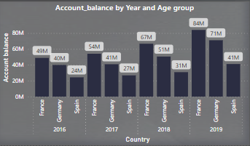

**2.** Identify the top 5 customers with the highest Estimated Salary in the last quarter of the year. (SQL)

* SQL Query:

SELECT CustomerID, Estimated_salary,Bank_date_of_joining as Date, quarter(Bank_date_of_joining) as Quarter FROM customer_data

WHERE quarter(Bank_date_of_joining) = 4

ORDER BY Estimated_salary DESC

limit 5;

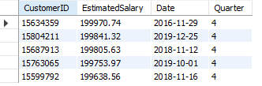

**3.** Calculate the average number of products used by customers who have a credit card. (SQL)

* SQL Query:

select round(avg(Number_of_products),2) as Average_number_of_products from bank_churn

where Credit_card = "Yes";

*(Check the Output in next page)*



**4.** Determine the churn rate by gender for the most recent year in the dataset.

* To determine churn rate, we will first calculate the churn rate of overall customers.
* With the help of DAX, we will create three measures as I have shown below:
  1. Customers = DISTINCTCOUNT(Bank_Churn[CustomerID])
  2. Customer Churned = CALCULATE(COUNT(Bank_Churn[Churn_status]), Bank_Churn[Churn_status] = "churned")
  3. Churn Rate = ([Customer Churned]/[Customers])
* Based on the above measures, we have drawn a bar chart to visualize the gender wise Churn rate. The churn rate for Female customers is 25% which is higher than the males that are 16.5%.

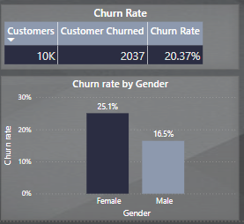

**5.** Compare the average credit score of customers who have exited and those who remain. (SQL)

* SQL Query:

select e.ExitCategory, round(avg(bc.CreditScore),2) as Average_credit_score from bank_churn bc

join exitcustomer e ON bc.Exited = e.ExitID

group by e.ExitCategory;

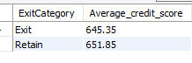

**6.** Which gender has a higher average estimated salary, and how does it relate to the number of active accounts? (SQL)

* SQL Query:

select g.GenderCategory, a.ActiveCategory, round(avg(ci.EstimatedSalary),2) as Average_estimated_salary

from customerinfo ci

join bank_churn bc ON ci.CustomerID = bc.CustomerID

Join activecustomer a ON bc.IsActiveMember = a.ActiveID

Join gender g ON ci.GenderID = g.GenderID

group by a.ActiveCategory, g.GenderCategory

order by Average_estimated_salary desc;

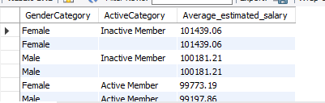

**7.** Segment the customers based on their credit score and identify the segment with the highest exit rate. (SQL)

* SQL Query:

With count_of_churned as

(select count(*) as churned_customers from bank_churn

where Exited = 1)

Select case

when CreditScore >=300 and CreditScore<580 then "Poor Credit score"

when CreditScore >=580 and CreditScore<670 then "Fair Credit score"

when CreditScore >=670 and CreditScore<740 then "Good Credit score"

when CreditScore >=740 and CreditScore<800 then "Very Good Credit score"

else "Excellent Credit score"

end as CreditScore_segment, count(*) as Total_customers,

ROUND((SELECT churned_customers FROM count_of_churned)/count(*),2) as Exit_rate

from bank_churn

group by CreditScore_segment

order by Exit_rate;

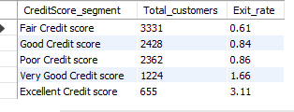

**8.** Find out which geographic region has the highest number of active customers with a tenure greater than 5 years. (SQL)

* SQL Query:

select g.GeographyLocation, count(*) As Highest_Active_customers from customerinfo ci

Join Bank_churn bc ON ci.CustomerID = bc.CustomerID

join geography g on ci.GeographyID = g.GeographyID

where bc.IsActiveMember = 1 and bc.Tenure>5

group by g.GeographyLocation

order by Highest_Active_customers desc

limit 3;

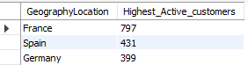

**9.** What is the impact of having a credit card on customer churn, based on the available data?

* With the help of below visual it seems, Customer churned for credit card holder are much higher than non-credit card holders.
* Credit card holder had 1424 customer churned and non-credit card holder had 613.

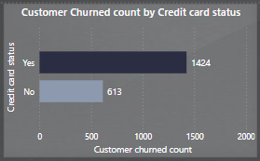

**10.** For customers who have exited, what is the most common number of products they had used?

* To determine the most common products customer have used, is to first create a DAX measure which calculate the number of customers churned.
* We then take a parameter such as Balance to see the number of products vs Account balance so that we can see the relationship of products used by customer having the balance with the Bank.
* Dormant customer seems to have an edge over the customers who are active. We can explore more with the Tenure as well to see if they have bought the products and been with the Bank over 3 years, this implies they are Loyal with the Bank.
* The graph goes down from 1 to 4 with Highest to lowest number of products owned by customers. One being the highest and four being the lowest.

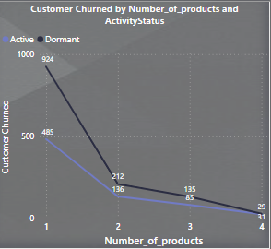

**11.** Examine the trend of customer joining over time and identify any seasonal patterns?

* First, we will extract the relevant data to observe any trend over years or months.
* Through the below SQL result, we can see the Total customers joined by the year and month and I have sorted the result by Total customers and joining year in a descending order.
* From the query we can observe a trend in 2019 the number of customers joining the bank has increased in a great number.
* The cluster is observed of customer joined in the last quarter of the year.
* France contributed the large number of customers coming from country.
* SQL Query:

select year(Bank_date_of_joining) as joining_year, month(Bank_date_of_joining) as joining_month, count(*) as Total_customers,

country, Age from customer_data

group by joining_year, joining_month, country, Age

order by Total_customers desc, joining_year desc;

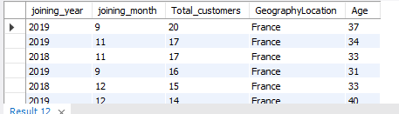

* **Trend Observed:**
* Analysis of 27.77% increase in count of customers joining the bank between 2018 and 2019. The increased volume of customers between year 2018 and 2019 is shown in the below waterfall chart.
* With this, we have observed some key metrics which can lead to a breakthrough of our analysis.
  1. France is the largest increase among country with 282 customers.
  2. ‘Female’ accounted for most of the increase among gender with 389 and for 331 for ‘male’.
  3. ’30-50’ accounted for most of the increase among other age groups.
  4. With 494 customers almost 27% were the credit card holders.

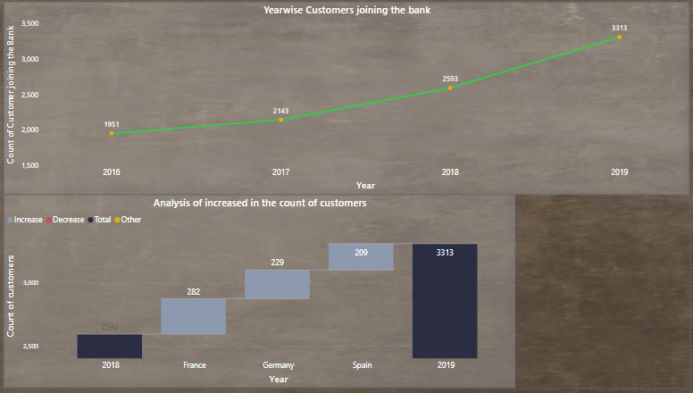

**12.** Analyze the relationship between the number of products and the account balance for customers who have exited.

* Filtered the data for churned customers, and we can see Account balance is drastically decreased between number of products 1 and 2 for the customers who are churned.
* Hence there is a relationship which can be seen where account balance is inversely proportional to the number of products.
* I have used an area chart to show the visuals.

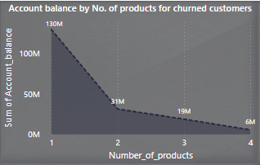

**13.** Identify any potential outliers in terms of balance among customers who have remained with the bank.

* ﻿Firstly, I have filtered out the data who have remained with the bank (non-churned)
* Across Age group, 30-50 had the most interesting recent trend in Account balance and started trending up in 2016, rising by 64.29% (values rising by: 52,249,346.26) in 3 years.﻿
* Likewise, customer base for the Age-group, 50+ had the lowest account balance observe which can further investigated by the team.

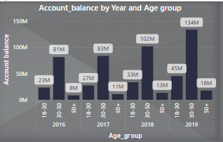

**14.** How many different tables are given in the dataset, out of these tables which table only consist of categorical variables?

* Columns that consist entirely of categorical variables are:
  + country
  + Gender
  + Credit_card_status
  + Activity_status
  + Churn_status

**15.** Using SQL, write a query to find out the gender wise average income of male and female in each geography id. Also rank the gender according to the average value. (SQL)

* SQL Query:

with ranked_salaries as (

select g.GenderID, geo.GeographyID, g.GenderCategory, geo.GeographyLocation, avg(ci.EstimatedSalary) as Average_Salary,

dense_rank() over(partition by g.GenderID order by avg(ci.EstimatedSalary) DESC) As ranked_salary

from customerinfo ci join gender g ON ci.GenderID = g.GenderID

Join geography geo ON ci.GeographyID = geo.GeographyID

group by g.GenderID, geo.GeographyID, g.GenderCategory, geo.GeographyLocation)

select rs.GenderCategory as Gender, rs.GeographyLocation as Country, round(rs.Average_salary,2) as

Average_Salary, rs.ranked_salary from ranked_salaries rs;

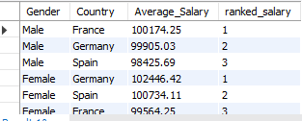

**16.** Using SQL, write a query to find out the average tenure of the people who have exited in each age bracket (18-30, 30-50, 50+).

* SQL Query:

select

case

when ci.Age>17 and ci.Age<=30 then '18-30'

when ci.Age>29 and ci.Age<=50 then '30-50'

else '50+'

end as Age_group,

round(avg(bc.Tenure),2) as Average_Tenure from bank_churn bc

join customerinfo ci ON bc.CustomerId = ci.CustomerId

where bc.Exited = 1 -- exited=1 defines the customers who are churned.

group by Age_group;

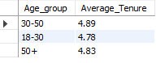

**17.** Is there any direct correlation between salary and balance of the customers? And is it different for people who have exited or not?

* To analyze the correlation between salary and balance for customers who have exited or retained with the bank, we can use scatter plots and add trendlines to visualize the relationship as you can see in the below snapshots.
* The trendline for churned customers is slightly below the 100k account balance mark, while the trendline for non-churned customers is slightly upwards over 100k mark. This indicates that, in general, non-churned customers tend to have higher account balances for a given salary level compared to churned customers.
* The positive slope of both trendlines suggests a positive correlation between salary and account balance, meaning higher salaries are associated with higher account balances, for both customer segments.
* Hence, it is confirmed that there is a direct correlation between these two variables.

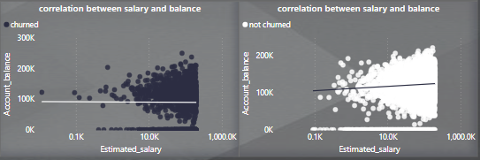

**18.** Is there any correlation between salary and Credit score of customers?

* To analyze the correlation between salary and credit score for the customers, we can use scatter plots and add trendlines to visualize the relationship as you can see in the below snapshots.
* Based on our scatter plot between average credit score and estimated salary the correlation is slightly decreasing, it suggests a weak negative correlation between these two variables.
* A weak negative correlation implies that as the estimated salary increases, the average credit score tends to decrease slightly, or vice versa. However, it's important to note that the correlation is weak, meaning the relationship is not very strong or pronounced.

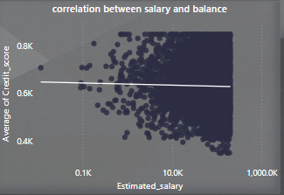

**19.** Rank each bucket of credit score as per the number of customers who have churned the bank.

* SQL Query:

with cte_credit_score_buckets as (

select bc.CustomerId,

CASE

when bc.CreditScore between 800 and 850 then 'Excellent'

when bc.CreditScore between 740 and 799 then 'Very Good'

when bc.CreditScore between 670 and 739 then 'Good'

when bc.CreditScore between 580 and 669 then 'Fair'

when bc.CreditScore between 300 and 579 then 'Poor'

else 'Unknown'

END as credit_score_bucket, bc.Exited

from bank_churn bc)

select credit_score_bucket, count(*) as num_churned_customers,

rank() over(order by count(*) desc) as rank_by_churned

from cte_credit_score_buckets

where Exited = 1

group by credit_score_bucket

order by rank_by_churned;

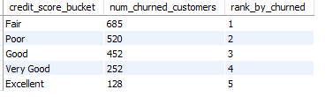

**20.** According to the age buckets find the number of customers who have a credit card. Also retrieve those buckets who have lesser than average number of credit cards per bucket.

* SQL Query:

with cte_age_buckets as (

select ci.CustomerId,

case

when ci.Age between 18 and 30 then '18-30'

when ci.Age between 31 and 50 then '31-43'

when ci.Age between 44 and 56 then '44-56'

when ci.Age between 57 and 66 then '57-66'

else '66+'

end as Age_group, bc.HasCrCard from customerinfo ci inner join bank_churn bc ON ci.CustomerId = bc.CustomerId),

cte_having_credit_card as (

select Age_group, count(case when HasCrCard =1 then 1 end) as num_credit_card_holders

from cte_age_buckets group by Age_group)

select Age_group, num_credit_card_holders from cte_having_credit_card

where num_credit_card_holders < (select avg(num_credit_card_holders) from cte_having_credit_card)

order by num_credit_card_holders;

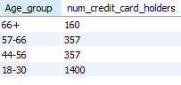

**21.** Rank the Locations as per the number of people who have churned the bank and average balance of the learners.

* SQL Query:

with cte_churn_info as (

select ci.GeographyID, bc.Exited, bc.Balance from customerinfo ci

INNER join bank_churn bc on ci.CustomerId = bc.CustomerId),

cte_churn_count as (

select GeographyID, COUNT(CASE WHEN Exited = 1 THEN 1 END) as churn_count from cte_churn_info

GROUP by GeographyID),

cte_avg_balance as (

select GeographyID, AVG(Balance) as avg_balance from cte_churn_info

GROUP BY GeographyID)

select g.GeographyLocation,

cc.churn_count,

round(ab.avg_balance,2) as Average_balance,

RANK() OVER (ORDER BY cc.churn_count DESC, ab.avg_balance DESC) as location_rank

from geography g

LEFT join cte_churn_count cc on g.GeographyID = cc.GeographyID

LEFT join cte_avg_balance ab on g.GeographyID = ab.GeographyID

order by location_rank;

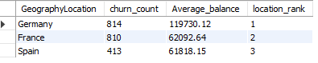

**22.** As we can see that the “CustomerInfo” table has the CustomerID and Surname, now if we have to join it with a table where the primary key is also a combination of CustomerID and Surname, come up with a column where the format is “CustomerID_Surname”.

* SQL Query:

select concat(CAST(CustomerId as CHAR), '_', Surname) as CustomerID_Surname

from customerinfo;

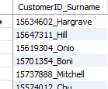

**23.** Without using “Join”, can we get the “ExitCategory” from ExitCustomers table to Bank_Churn table? If yes do this using SQL.

* Yes, we can retrieve the "ExitCategory" from the "ExitCustomers" table and merge it into the "Bank_Churn" table without using a JOIN by using a subquery. Here's the Sql query:
* SQL Query:

SELECT bc.*, (SELECT ExitCategory FROM exitcustomer ec WHERE ec.ExitID = bc.Exited) AS Exit_Category

FROM Bank_Churn bc;

* In this query, the subquery (SELECT ExitCategory FROM ExitCustomers ec WHERE ec.CustomerId = bc.CustomerId) is used to fetch the "ExitCategory" from the "ExitCustomers" table for each customer in the "Bank_Churn" table. The subquery is correlated to the outer query by matching the "CustomerId" from both tables.

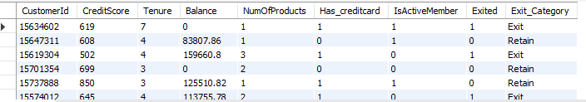

**24.** Were there any missing values in the data, using which tool did you replace them and what are the ways to handle them?

* We can calculate the number of null values in each column from Bank_Churn and Customer_info table.
* As you can see in the below snap, we did not get any null value from all the columns.
* If there would be a null value in our data, here are couple of methods through which we can handle missing values:
  + we could have done Listwise deletion, but it can lead to a loss of data, especially if missing values are frequent.
  + Replacing missing values with the average (mean), Middle value (median) or the most frequent value (mode) for the specific column. This can be a good option if the missing values are random, and the data distribution is relatively normal.



**25.** Write the query to get the customer ids, their last name and whether they are active or not for the customers whose surname  ends with “on”.

* SQL Query:

select ci.CustomerId, ci.Surname,

CASE when bc.IsActiveMember = 1 then 'Active' else 'Inactive' END as Activity_status

from customerinfo ci

join bank_churn bc on ci.CustomerId = bc.CustomerId

where ci.Surname like '%on';

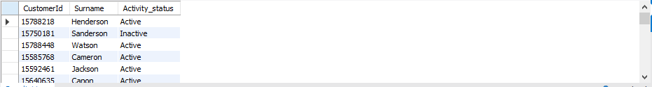

**Subjective**

**1.** Customer Behaviour Analysis: What patterns can be observed in the spending habits of long-term customers compared to new customers, and what might these patterns suggest about customer loyalty?

* By analyzing spending habits of long-term customers compared to new customers, we can gain valuable insights into customer loyalty.
* Created a calculated column named "Customer Category" to segment customers:
  + "Long-Term": Tenure > 3 years
  + "New": Tenure <= 3 years
* Created a Stacked bar chart showing the number of cutomers within two customer segments as defined.
* Within each category, I have also included a different category which is credit card information. Credit card status shows the customer with the credit score and the average amount spent in both segments.
* Some key insights to summarize from our analysis:
  + Customer under 'New' segment in Excellent category made up 11.52% in Average account balance.
  + Germany had the highest Average of account balance at 119.5K followed by France at 62K and Spain 61.8K.

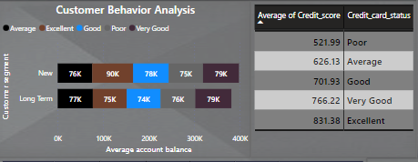

**2.** Product Affinity Study: Which bank products or services are most commonly used together, and how might this influence cross-selling strategies?

* The most common services used by customers are Credit card and NumOfProducts are the number of products customers has purchased.
* I have created a matrix showing the less number if products tend to have more number of credit cards.
* if customers who have purchased the more products are also likely to go for Credit card service, So this can impact the cross-selling strategy where bank wants to sell its service where customer has already the three or four number of products.

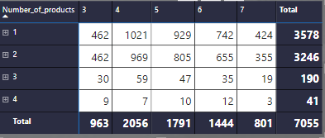

**3.** Geographic Market Trends:How do economic indicators in different geographic regions correlate with the number of active accounts and customer churn rates?

* Talking about economic factors affecting churn rate in different geographic regions such as Germany, Spain and France
* We can see Active customer in Germany rose up to 51.60% of Churn Rate and have the lowest number of products bought by the customers.
* France being the second region contributing 11.5% of churn rate and lastly Spain with the 10.7% of churn rate.

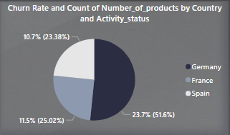

**4.** Risk Management Assessment: Based on customer profiles, which demographic segments appear to pose the highest financial risk to the bank, and why?

* To assess the financial risk posed by different demographic segments based on customer profiles, we can create a measure which calculates the financial risk score by summing the product of Account Balance and CreditScore for churned customers (where Exited = 1). Higher scores indicate higher financial risk.
* DAX Expression:

Financial Risk Score = SUMX (FILTER('bank_churn', [Exited] = 1), [Balance] * [CreditScore])

* We have created a scatter plot visualization for Financial Risk Score by Age.
* I have also taken gender into consideration and created a Column chart visualization for Financial Risk Score by Gender.
* scatter plot of financial risk scores against age shows a slightly decreasing trendline, lower than a straight line, it could indicate the following:
* Lower risk with increasing age: This could imply that older customers generally pose a lower financial risk to the bank compared to younger customers.
* Stability and financial maturity: With increasing age, individuals typically have more stable income sources, better financial management skills, and a lower propensity for defaulting on loans or engaging in risky financial behaviour.
* Column chart shows the positive increase of financial risk score for Female customers.

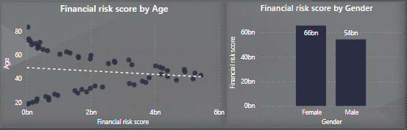

**5.** Customer Lifetime Value Forecast: How would you use the available data to model and predict the lifetime (tenure) value of different customer segments?

* ﻿To predict the lifetime (tenure) value of different customer segments, I have Calculated Customer Lifetime Value (CLV):
  + Create a new calculated column in my dataset to calculate CLV for each customer, with the help of below formula.
  + CLV = Balance * Tenure * (1 - Churn_Rate)
  + where Churn_Rate is the rate at which customers are leaving the bank. This rate is based on the churn_status column (churned/not churned).
* Tenure of six accounted for 25.00% of Sum of Customer Lifetime Value.

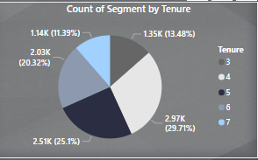

**6.** Marketing Campaign Effectiveness: How could you assess the impact of marketing campaigns on customer retention and acquisition within the dataset? What extra information would you need to solve this?

* Firstly, we should identify the marketing campaign data and for that we would need tables that contain information about marketing campaigns, such as campaign name, start date, end date, target audience, and channels used.
* Secondly, we will link campaign data with customer data by joining the marketing campaign data with the customer data using a common identifier (e.g., CustomerId) to analyze the impact on customer behavior.
* Later we can calculate customer retention and acquisition rates by defining retention as the percentage of customers who remained with the bank after the campaign compared to before, and acquisition as the percentage of new customers acquired during the campaign period.
* For visualizations we can create Line charts or Bar charts to compare retention and acquisition rates before, during, and after the campaigns. This can help identify the impact of each campaign on customer behavior.

**7.** Customer Exit Reasons Exploration: Can you identify common characteristics or trends among customers who have exited that could explain their reasons for leaving?

* To identify common characteristics or trends among customers who have exited the bank, we can perform a detailed analysis of the data focusing on churned customers.
* We will start by filtering the dataset to include only customers who have churned (Exited).
* We will explore the Demographics by looking at the demographic information (gender, age, country) of churned customers to see if there are any patterns. For example, are there certain countries or age groups more likely to churn?
* I found age-group 18-30+ has the lowest churn rate comparing to the age group of 30-50
* Females have the highest churn rate on all three age groups.

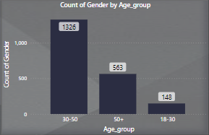

* France is the leading country with the highest estimated salary of customers with 84M, with that Germany and Spain are the other two having estimated salary 80M and 43M

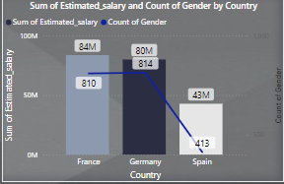

* Customer with Credit card holder – Country wise and Year wise, the number of highest products brought are with the France whereas Germany and Spain are the rest two countries.

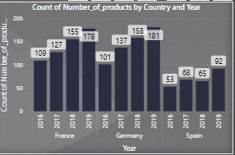

* We can check the tenure as well, whether new customers are more likely to get churned. I have created a column chart to see the number of customers with the Tenure to get the high-level scenario of tenure and customers relationship.

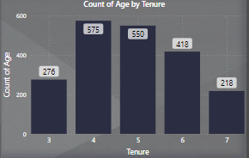

**8.** Are 'Tenure', 'NumOfProducts', 'IsActiveMember', and 'EstimatedSalary' important for predicting if a customer will leave the bank?

* To determine if 'Tenure', 'NumOfProducts', 'IsActiveMember', and 'EstimatedSalary' are important for predicting if a customer will leave the bank, we can create visualizations and perform analysis using Power BI.
* Created a stacked column chart for number of products by churn status and Activity status. Customers with the active status tends to stay with the Bank rather than non-active status.
* Also, created a donut chart to visualize the churn status by Activity status and as we have seen customer churn rate is 20% but the active members don’t make difference.
* For active members, number of customers churned are 4849.
* For inactive members, number of customers churned are 5151.

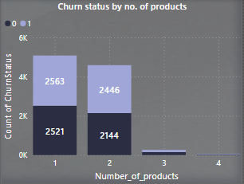 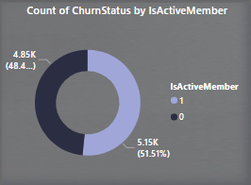

**9.** Utilize SQL queries to segment customers based on demographics and account details.

* To segment customers based on demographics and account details using SQL, I have used the following queries:
* Segmentation by Gender:

SELECT ci.GenderID, COUNT(*) AS TotalCustomers, round(AVG(ci.Age)) AS AvgAge, round(AVG(bc.Balance),2) AS AvgBalance,

round(AVG(bc.NumOfProducts),2) AS AvgNumOfProducts, round(AVG(ci.EstimatedSalary),2) AS AvgSalary

FROM customerInfo ci join bank_churn bc ON ci.CustomerId = bc.CustomerId

GROUP BY GenderID;

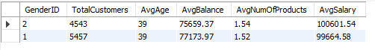

* Segmentation by Country:

SELECT g.GeographyLocation, COUNT(*) AS TotalCustomers, round(AVG(ci.Age)) AS AvgAge, round(AVG(bc.Balance),2) AS AvgBalance,

round(AVG(bc.NumOfProducts),2) AS AvgNumOfProducts, round(AVG(ci.EstimatedSalary),2) AS AvgSalary

FROM customerInfo ci join bank_churn bc ON ci.CustomerId = bc.CustomerId

join geography g ON ci.GeographyID = g.GeographyID

GROUP BY g.GeographyLocation;

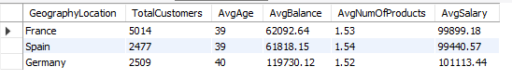

* Segmentation by Credit Card Status:

SELECT cc.category, COUNT(*) AS TotalCustomers, round(AVG(ci.Age)) AS AvgAge, round(AVG(bc.Balance),2) AS AvgBalance,

round(AVG(bc.NumOfProducts),2) AS AvgNumOfProducts, round(AVG(ci.EstimatedSalary),2) AS AvgSalary

FROM customerInfo ci join bank_churn bc ON ci.CustomerId = bc.CustomerId

join creditcard cc ON bc.HasCrCard = cc.CreditID

GROUP BY cc.category;

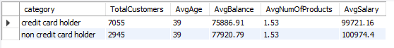

**10.** How can we create a conditional formatting setup to visually highlight customers at risk of churn and to evaluate the impact of credit card rewards on customer retention?

* To create a conditional formatting setup to visually highlight customers at risk of churn and to evaluate the impact of credit card rewards on customer retention, follow these steps:
* First, identify at-risk customers by using the churn_status column to know who have churned (exit) and those who have not (retain). We can create a measure to calculate the churn rate.
* To apply conditional formatting for at-risk customers:
  + Go to the visualization where you want to highlight at-risk customers (a chart or table).
  + Select the column representing customerID or names.
  + Go to the 'Conditional Formatting' option in the formatting pane.
  + Choose 'Font Color' or 'Background Color' based on your preference.
  + Define the condition based on the churn rate measure. For example, if the churn rate is above a certain threshold, set the formatting to highlight those customers.
* To evaluate the impact of credit card rewards:
  + We can create a new measure to calculate the retention rate for customers with credit cards and without credit cards separately.
  + Use a visualization (bar/column chart) to compare the retention rates of these two groups.
  + Lastly, we can apply the same conditional formatting as above to visually highlight any differences in retention rates between credit card and non-credit card holders.

**11.** What is the current churn rate per year and overall, as well in the bank. Can you suggest some insights to the bank about which kind of customers are more likely to churn and what are the different strategies that can be used to decrease the churn rate.

* To determine the current churn rate per year and overall, in the bank, as well as to provide insights and strategies to decrease the churn rate.
* I used DAX measure Churn rate which I previously calculated.
* Created visualizations to analyze the churn rate based on demographics (age, gender, country), credit score, tenure, number of products, credit card status and activity status.
* Use slicers and filters to drill down into specific segments of customers who are more likely to churn.

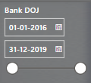

* Visualizations for all the demographics:

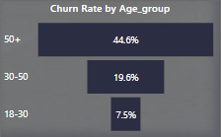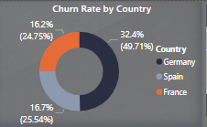

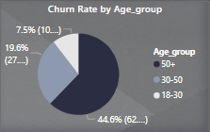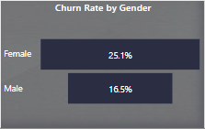

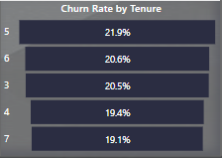 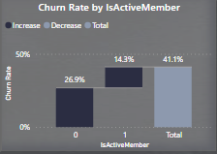

* Insights and strategies:
  + Based on my analysis, The customers with lower credit scores, lower balances, shorter tenures, fewer products, and lower salaries might be more likely to churn.
  + Strategies to decrease the churn rate:
  + Improve customer engagement through personalized interactions and targeted marketing campaigns.
  + Offer loyalty programs or incentives to retain customers.
  + Improve service delivery and address customer complaints promptly.

**12.** Create a dashboard incorporating all the KPIs and visualization related metrics. Use a slicer in order to assist in selection in the dashboard.

* Created multiple reports to answer the Subjective problems.
* Please check all the reports attached below.

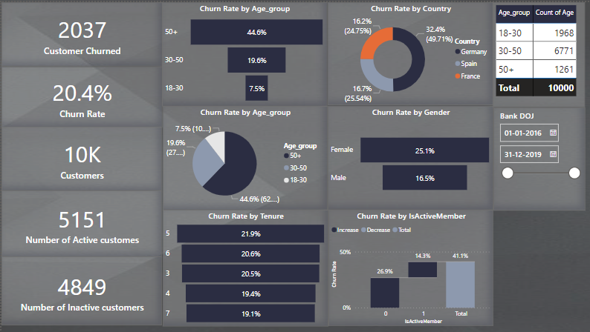

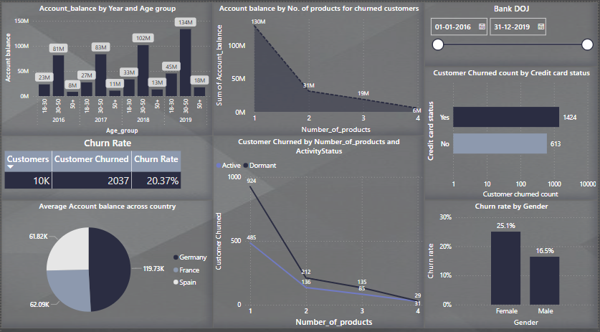

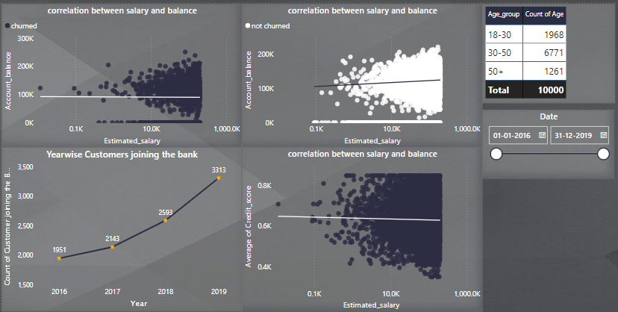

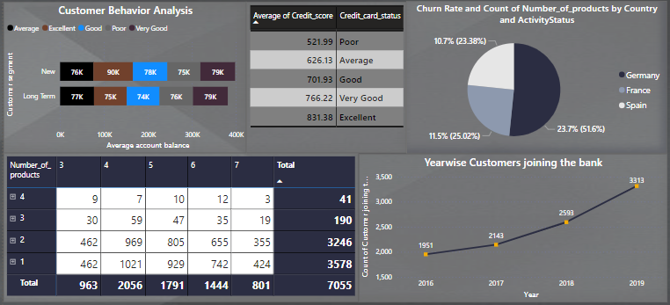

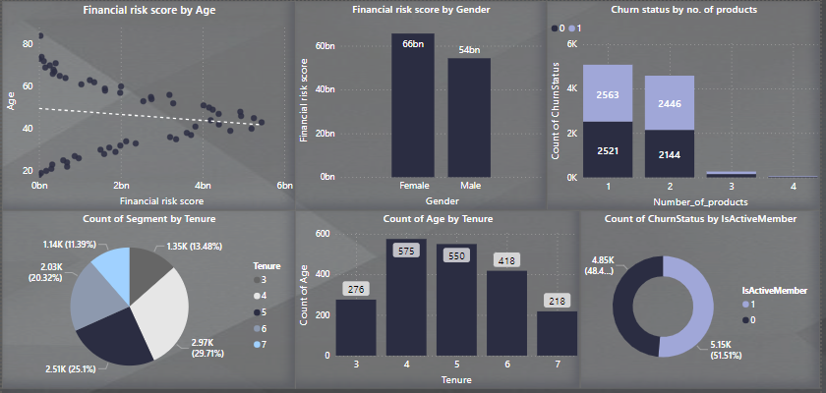

**13.** How would you approach this problem, if the objective and subjective questions weren't given?

* If the objective and subjective questions weren't given, I would approach the problem by first familiarizing myself with the datasets provided.
* I would try to to understand the distribution, patterns, and relationships within the data. This would involve checking for missing values, outliers, and data quality issues.
* Next, I would identify key variables that could potentially impact customer churn, such as credit score, tenure, balance, number of products, credit card status, activity status, estimated salary, and demographics.
* I would use data visualization techniques to explore relationships between demographics with the churn rate.
* Finally, I would use the results of the analysis to develop strategies to reduce customer churn, improve service delivery, and enhance customer satisfaction.
* This could involve targeting specific customer segments with personalized offers, improving customer service processes, or implementing customer retention programs.

**14.** In the “Bank_Churn” table how can you modify the name of “HasCrCard” column to “Has_creditcard”?

* To modify the name of the "HasCrCard" column to "Has_creditcard" in the "Bank_Churn" table, following SQL query can be used:

ALTER TABLE Bank_Churn RENAME COLUMN HasCrCard TO Has_creditcard;

Output:

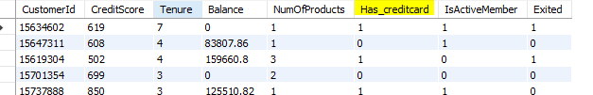

*----------* ***End Of Document*** *----------*